Project Design Phase-II
Technology Stack (Architecture & Stack)

Date | 13 July 206
Team ID | SWTID-2026-9658
Project Name | Customer Registry
Maximum Marks | 4 Marks

Technical Architecture:
The Deliverable shall include the architectural diagram as below and the information as per the table1 & table 2
Guidelines:
Include all the processes (As an application logic / Technology Block)
Provide infrastructural demarcation (Local / Cloud)
Indicate external interfaces (third party API’s etc.)
Indicate Data Storage components / services
Indicate interface to machine learning models (if applicable)
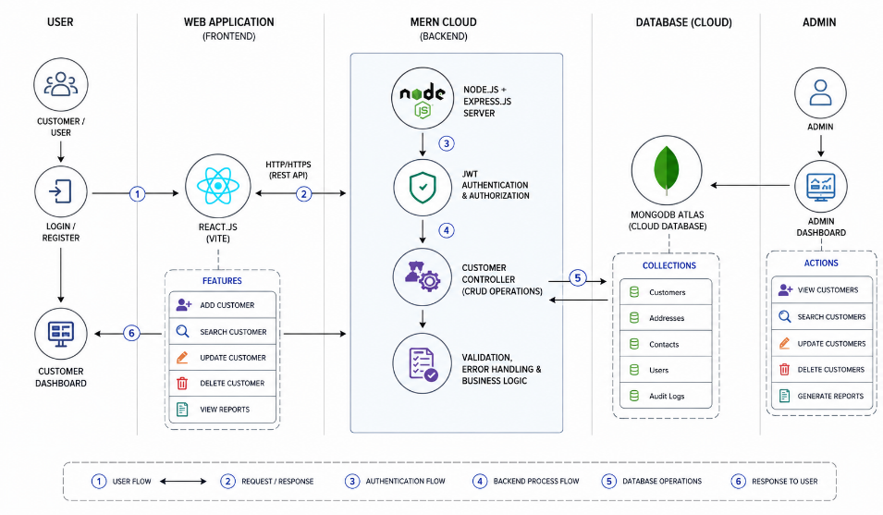

Table-1 : Components & Technologies:
S.No | Component | Description | Technology
 | User Interface | Single Page Application (SPA) dashboard for ticket submission, tracking logs, and administrative filtering. | React.js, Tailwind CSS, JavaScript
 | Application Logic-1 | Web application routing, server-side data sanitization, middleware logic, and request handling | Node.js, Express.js framework.
 | Application Logic-2 | Object-Document Mapping (ODM) logic to define data models, strict schemas, and perform operations. | Mongoose library.
 | Application Logic-3 | Token tokenization and secure middleware validation for session safety. | jsonwebtoken (JWT) library.
 | Database | Local non-relational document data storage engine for rapid development environments | MongoDB Community Server
 | Cloud Database | Cloud-hosted, distributed database instance for live application persistence. | MongoDB Atlas Cluster.
 | File Storage | File upload storage requirements for image evidence attachments on tickets. | Cloudinary API / Multer local storage engine.
 | External API-1 | Automated dispatch system for email registration validation and ticket confirmations. | Nodemailer service API.
 | External API-2 | Not required for initial MVP version / Left blank. | N/A
 | Machine Learning Model | Not required for initial MVP version / Left blank. | N/A
 | Infrastructure (Server / Cloud) | Local development execution and remote multi-region cloud deployment. | Local: Node runtime environment.  Cloud: Render platform hosting / Vercel.

Table-2: Application Characteristics:
S.No | Characteristics | Description | Technology
 | Open-Source Frameworks | End-to-end framework stack components utilized to ensure zero software licensing acquisition fees. | React, Node.js, Express, Mongoose.
 | Security Implementations | Role-based authorization layers, validation checks, and secure hashed password storage. | JSON Web Tokens (JWT), Bcrypt password hashing.
 | Scalable Architecture | Clean decoupling of user dashboard interfaces from server-side query processing steps. | 3-Tier Distributed Architecture (React Frontend → Node Backend → MongoDB Database).
 | Availability | Maintaining persistent connection sessions and zero single points of backend failure. | MongoDB Atlas multi-region replication clusters.
 | Performance | Low latency client updates, state adjustments, and index-based quick lookups. | React state management re-rendering and MongoDB database indexing.

